# Project Name: Building A Restaurant Website with Bootstrap.

## GitHub Link:

## <https://github.com/tamasjit/myjavaproject/tree/master/Phase%204/Phase-4_Practice_Project/q1_Restaurant_Project>

## Output:

### Landing Page:

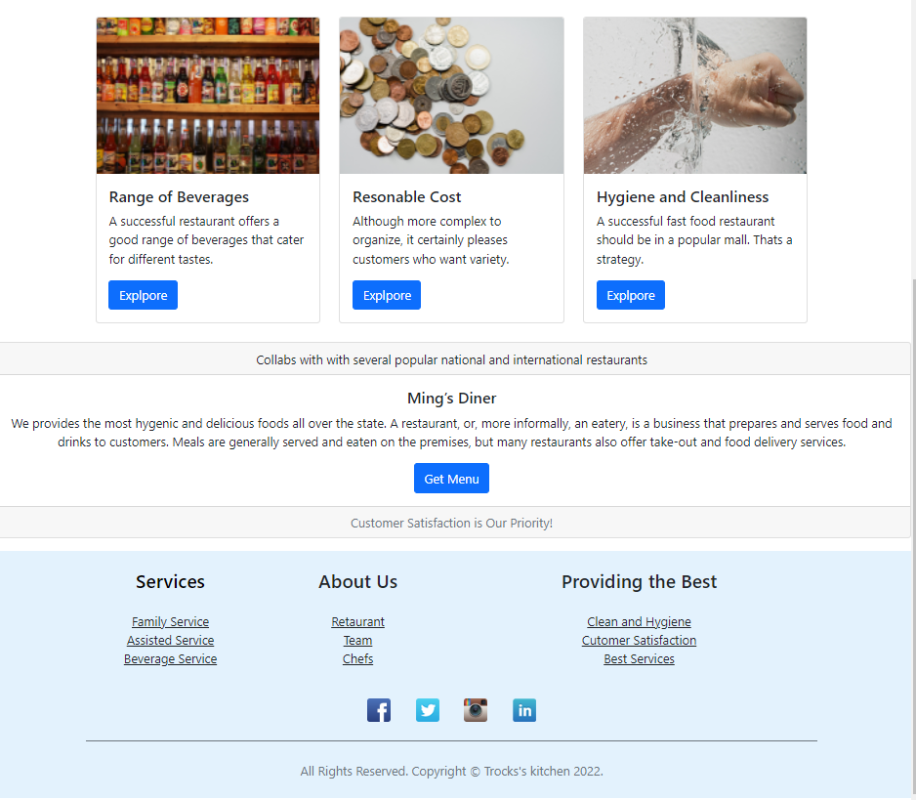

### About Us Page:

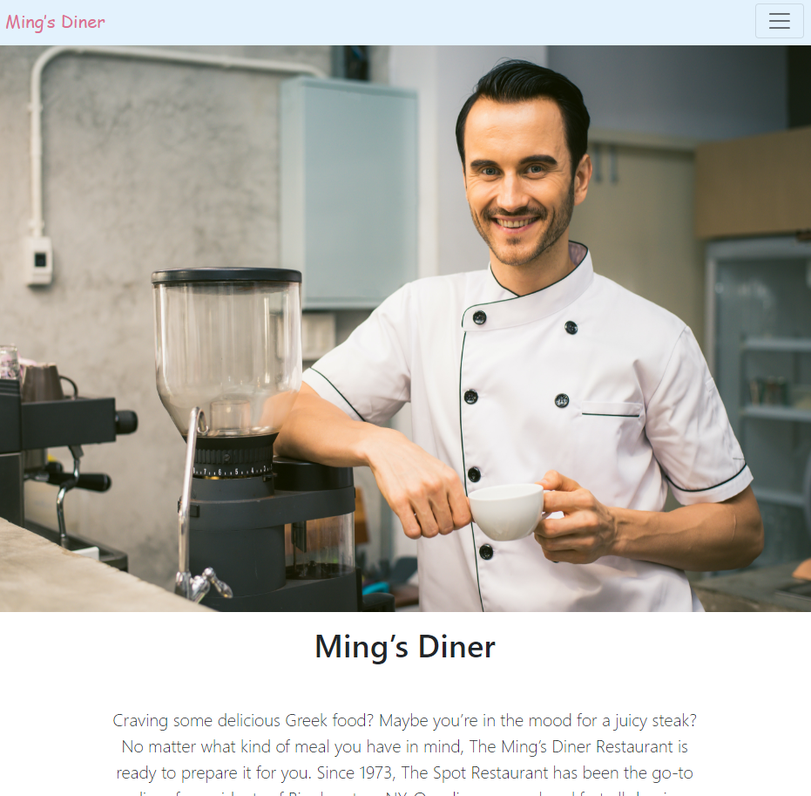

### User Data Editing:

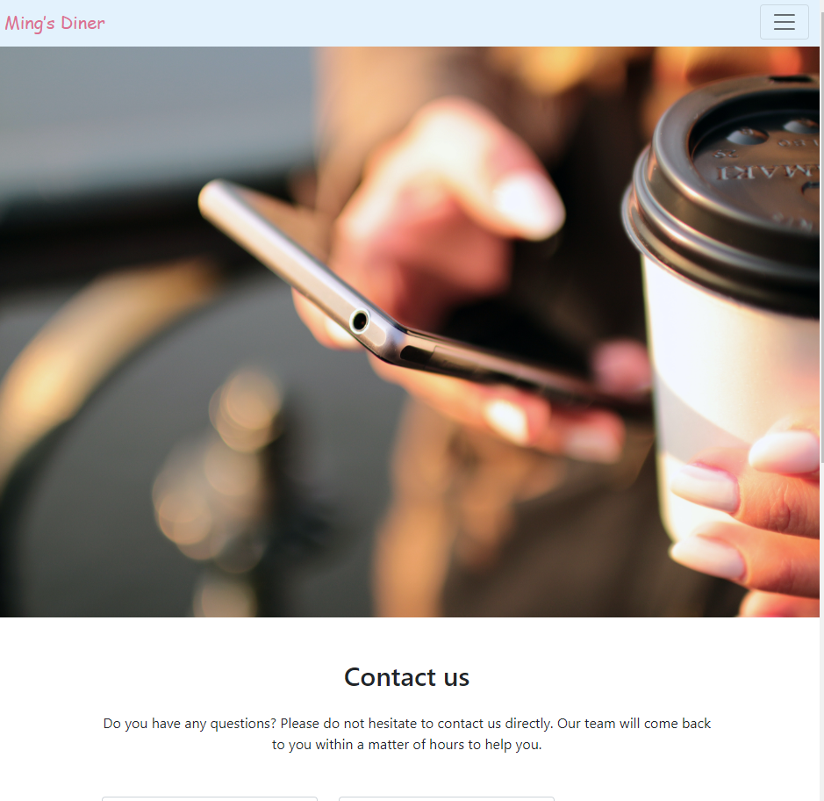

### Contact Form:

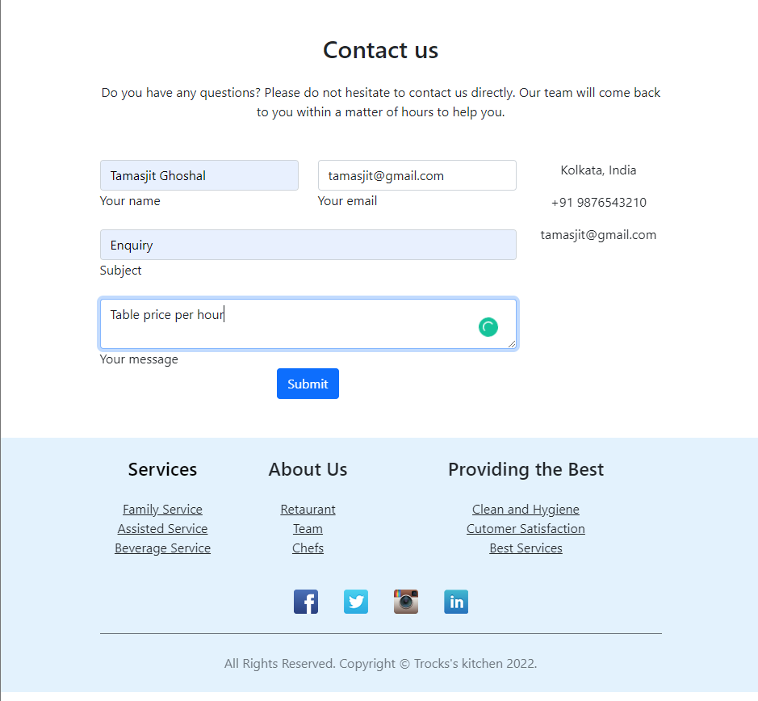

### Thank you page:

